

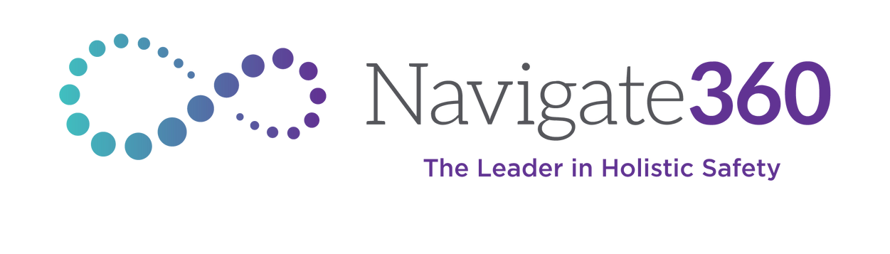Important Information on

Child Trafficking Awareness Curriculum

# Dear Parents and Guardians,

We hope this letter finds you well. As part of our commitment to student safety and well-being, we are implementing Navigate360’s age-appropriate curriculum on child trafficking prevention and awareness for students in grades 6–12. Our goal is to equip students with knowledge and strategies to recognize and respond to unsafe situations while fostering open communication between children and trusted adults.

# What Is Child Trafficking?

Child trafficking is the use of coercion and/or manipulation to exploit a person under the age of 18, usually for their labor or for sexual purposes.

# Why Is This Curriculum Important?

Child trafficking is a serious issue that affects communities nationwide. While it may seem like it won’t happen in your community, traffickers often target and groom vulnerable children through social media, peer relationships, or even in public places. By educating students on safety, recognizing warning signs, teaching refusal strategies, and understanding personal boundaries, we empower children to protect themselves and seek help when needed.

# Key Things to Know

In 2022, the National Center for Missing & Exploited Children (NCMEC) received more than 19,000 reports of child sex trafficking from all 50 states, Washington, D.C., and Puerto Rico.

Child trafficking does not always involve kidnapping; it can occur through coercion, manipulation, and exploitation.

Traffickers often use online platforms to connect with potential victims. Children of all ages, backgrounds, and communities can be targeted.

Education and awareness significantly reduce risk by equipping children with knowledge and the confidence to seek help.

# How You Can Support Your Student at Home

We encourage parents and guardians to engage in open and age-appropriate conversations with their children. Below are some suggested topics based on grade level:

# Grades 6–8

Talk about social media dangers, including grooming tactics used by traffickers. Discuss peer pressure and how to set boundaries in friendships and relationships. Encourage them to be cautious when communicating with people they don’t know online.

# Grades 9–12

Teach them how to identify red flags in relationships, friendships, and online interactions.

Discuss human trafficking myths versus realities to help them make informed decisions.

Empower them to advocate for their own safety with trusted adults and to look out for their peers.

# Additional Information and Resources

National Human Trafficking Hotline: <https://humantraffickinghotline.org/en> or 1- 888-373-7888 (text: 233733)

National Center for Victims of Crimes: [www.victimsofcrime.org/child-trafficking](https://www.victimsofcrime.org/child-trafficking%20%20%20%20%20)

U.S. Department of Justice: [www.justice.gov/humantrafficking/resources](http://www.justice.gov/humantrafficking/resources) Love146: <https://love146.org/caregivers/>

We understand that these conversations can be challenging, but they are essential in keeping our children safe. If you have any questions or concerns about the curriculum or how to approach these discussions at home, please don’t hesitate to reach out.

Thank you for partnering with us in prioritizing the safety and well-being of all students. Sincerely,

Red Oak ISD

Counseling & Family Services